Day 3 –secure coding practice and owasp mobile top 10

Downloaded the zip file and extracted:

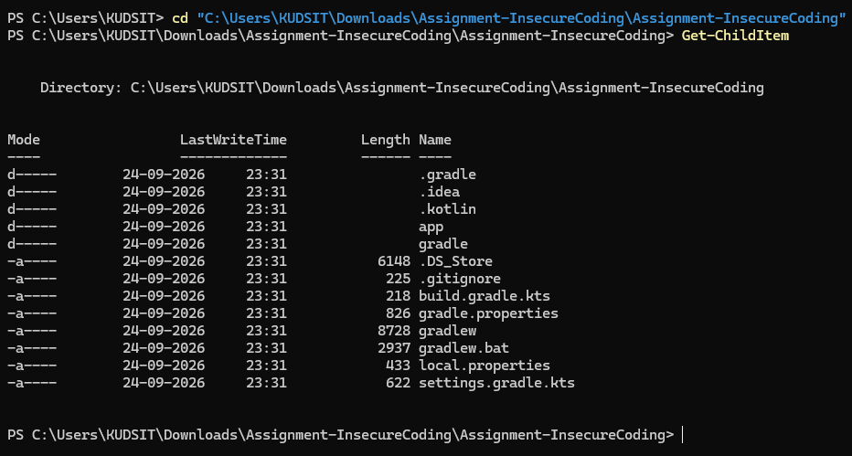

Task 1: 1. Find the Insecure coding practices used in the application
Since the project is Kotlin/Android, run these all at once from your current folder:
$src = Get-ChildItem .\app\src\main -Recurse -File -Include *.java,*.kt

"===== 1. LOGGING / SENSITIVE DATA ====="
$src | Select-String -Pattern 'Log\.(d|e|i|v|w)|println|password|token|secret' |
ForEach-Object {
"{0}:{1}: {2}" -f $_.Filename, $_.LineNumber, $_.Line.Trim()
}
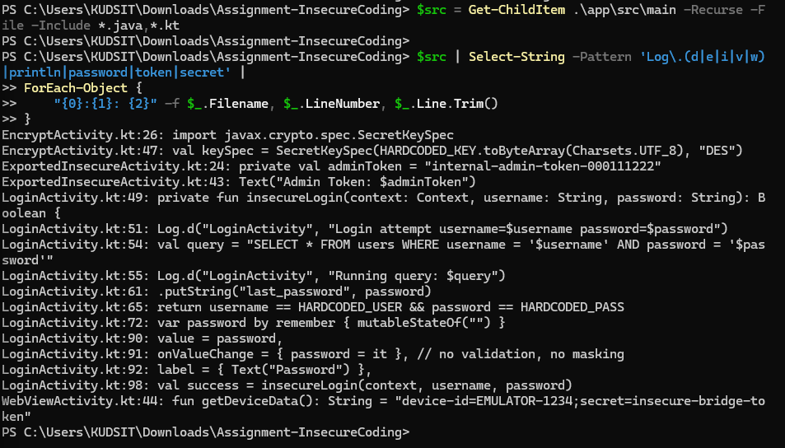

"===== 2. WEBVIEW / SSL ====="
$src | Select-String -Pattern 'WebView|setJavaScriptEnabled|onReceivedSslError|handler\.proceed|loadUrl' |
ForEach-Object {
"{0}:{1}: {2}" -f $_.Filename, $_.LineNumber, $_.Line.Trim()
}
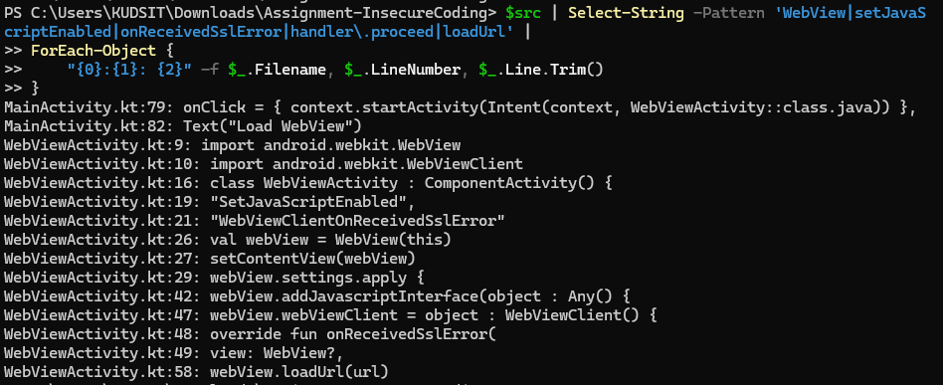

"===== 3. CRYPTOGRAPHY ====="
$src | Select-String -Pattern 'Cipher|MessageDigest|MD5|SHA-1|DES|ECB|AES|SecretKey|KeyStore' |
ForEach-Object {
"{0}:{1}: {2}" -f $_.Filename, $_.LineNumber, $_.Line.Trim()
}
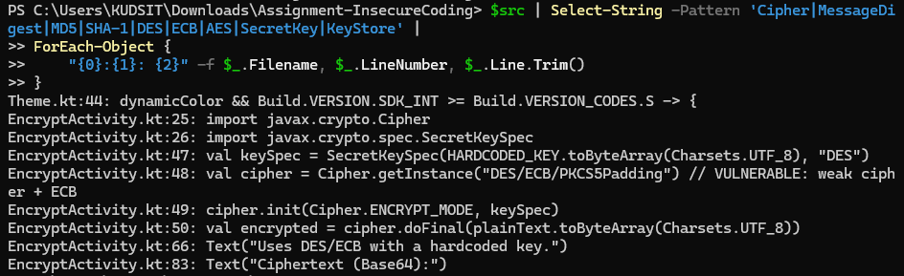

"===== 4. ANDROID MANIFEST ====="
Get-Content .\app\src\main\AndroidManifest.xml |
Select-String -Pattern 'exported|debuggable|allowBackup|usesCleartextTraffic|permission' |
ForEach-Object {
$_.Line.Trim()
}
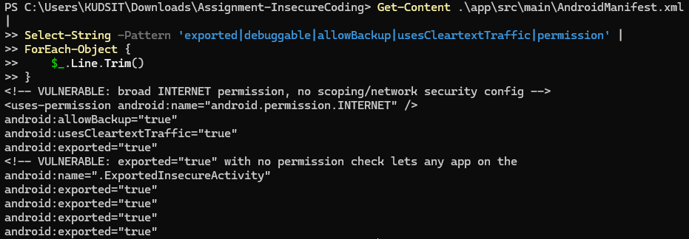

What these are doing
We're basically searching the source for:
- 🔴 Sensitive data logging
- 🔴 Unsafe WebView / SSL handling
- 🔴 Weak/insecure cryptography
- 🔴 Insecure Android components/configuration

I would use these 3 because they are extremely clear and easy to explain:
# | Insecure practice | Evidence | OWASP Mobile Top 10 2024
1 | SQL Injection | LoginActivity.kt:54 concatenates username/password into SQL | M4 – Insufficient Input/Output Validation
2 | DES/ECB + hardcoded key | EncryptActivity.kt:47–48 | M10 – Insufficient Cryptography
3 | Exported activity without authorization | ExportedInsecureActivity + android:exported="true" | M3 – Insecure Authentication/Authorization
These mappings match the current OWASP Mobile Top 10 2024 categories.

🔴 Finding 1 — SQL Injection
You found:
val query = "SELECT * FROM users WHERE username = '$username' AND password = '$password'"
The problem is that user-controlled input is directly concatenated into an SQL query.
An attacker could manipulate the input so the SQL query behaves differently from what the developer intended.
OWASP specifically identifies concatenating untrusted input into SQL queries instead of using parameterized APIs as an unsafe-data-handling weakness.
OWASP: M4 – Insufficient Input/Output Validation.

🔴 Finding 2 — DES/ECB + hardcoded key
You found:
val keySpec = SecretKeySpec(
HARDCODED_KEY.toByteArray(Charsets.UTF_8),
"DES"
)

val cipher = Cipher.getInstance("DES/ECB/PKCS5Padding")
This is actually two problems in one:
- DES is an outdated/weak encryption algorithm.
- ECB is an insecure encryption mode for general sensitive-data encryption.
- The encryption key is also hardcoded in the application.
OWASP's current mobile guidance classifies broken/risky cryptographic algorithms and insecure encryption modes under improper encryption/insufficient cryptography.
OWASP: M10 – Insufficient Cryptography.

🔴 Finding 3 — Exported Activity
We have:
android:exported="true"
and:
ExportedInsecureActivity.kt
The source also contains:
private val adminToken = "internal-admin-token-000111222"
This is particularly good because the component is exposed to other applications, while the code appears to contain privileged/admin functionality.
OWASP specifically describes exported Android components without adequate authentication/authorization as a weakness that can allow other apps to invoke sensitive functionality.
OWASP: M3 – Insecure Authentication/Authorization.

Task 1: Identify Insecure Coding Practices
The application source code was reviewed using Android Studio/source-code inspection. Three major insecure coding practices were identified.

1. SQL Injection – LoginActivity.kt
The application directly concatenates user-controlled username and password values into an SQL query:
val query = "SELECT * FROM users WHERE username = '$username' AND password = '$password'"
This is insecure because user input is inserted directly into the SQL statement without parameterized queries or proper input handling. A malicious input could alter the intended SQL query and potentially allow unauthorized database access.

2. Weak Encryption – EncryptActivity.kt
The application uses a hardcoded DES key and the insecure ECB encryption mode:
private const val HARDCODED_KEY = "8bytekey"

val keySpec = SecretKeySpec(
HARDCODED_KEY.toByteArray(Charsets.UTF_8),
"DES"
)

val cipher = Cipher.getInstance("DES/ECB/PKCS5Padding")
This is insecure because DES is an outdated and weak encryption algorithm, while ECB mode does not provide adequate protection for structured data. The encryption key is also hardcoded inside the application, making it easier to extract.

3. Exported and Unprotected Activity – ExportedInsecureActivity.kt
The application contains an activity intended to be externally accessible without proper protection. The source itself states:
Text("This screen is exported and unprotected. Any app can reach it.")
The activity also contains sensitive credentials:
private val apiKey = "[REDACTED]"
private val adminToken = "[REDACTED]"
The corresponding Android manifest contains components with:
android:exported="true"
An exported component without appropriate authentication or authorization controls can potentially be accessed by other applications on the device. Additionally, storing sensitive credentials directly in application source code exposes them to anyone who can inspect or reverse-engineer the application.

Task 1 – Summary
No. | File | Insecure coding practice
1 | LoginActivity.kt | Direct concatenation of user input into SQL query
2 | EncryptActivity.kt | DES/ECB encryption with a hardcoded key
3 | ExportedInsecureActivity.kt | Exported, unprotected activity containing sensitive credentials
Task 1 complete. ✅

1.
Get-ChildItem .\app\src\main -Recurse -Filter LoginActivity.kt | Get-Content Get-ChildItem .\app\src\main -Recurse -Filter EncryptActivity.kt | Get-Content Get-ChildItem .\app\src\main -Recurse -Filter ExportedInsecureActivity.kt | Get-Content
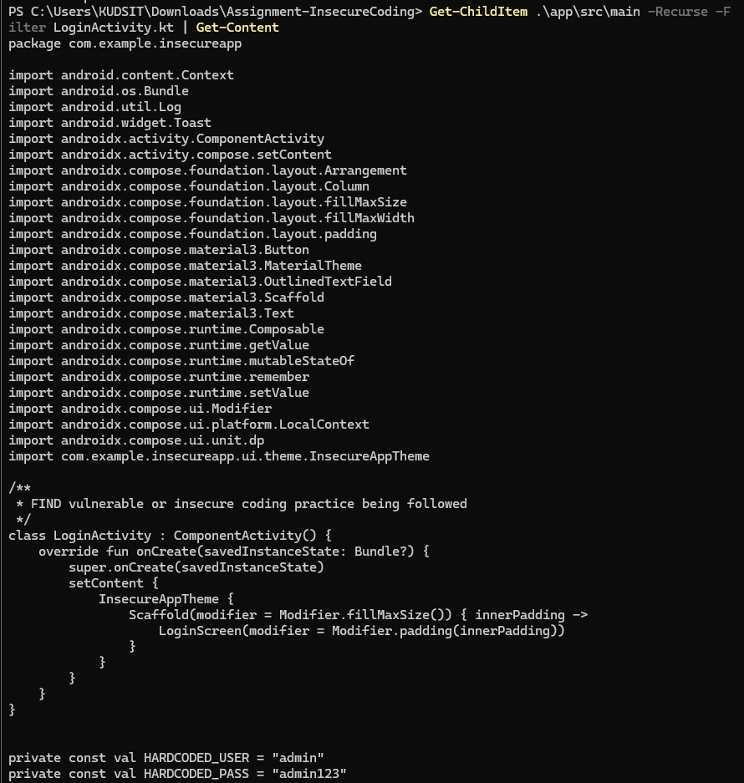
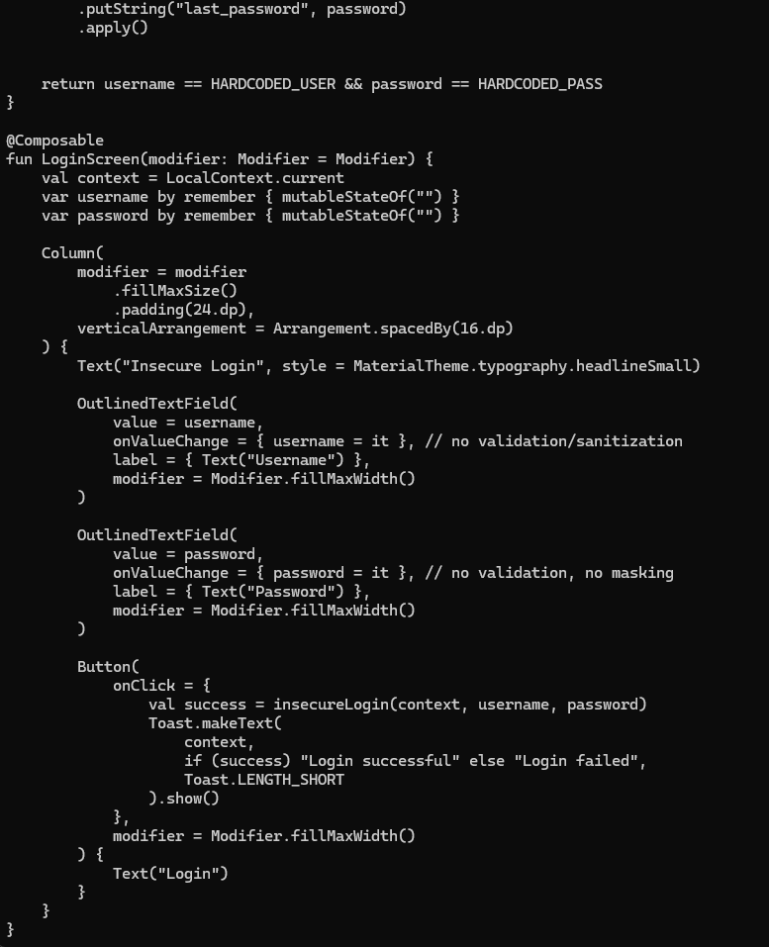
2.
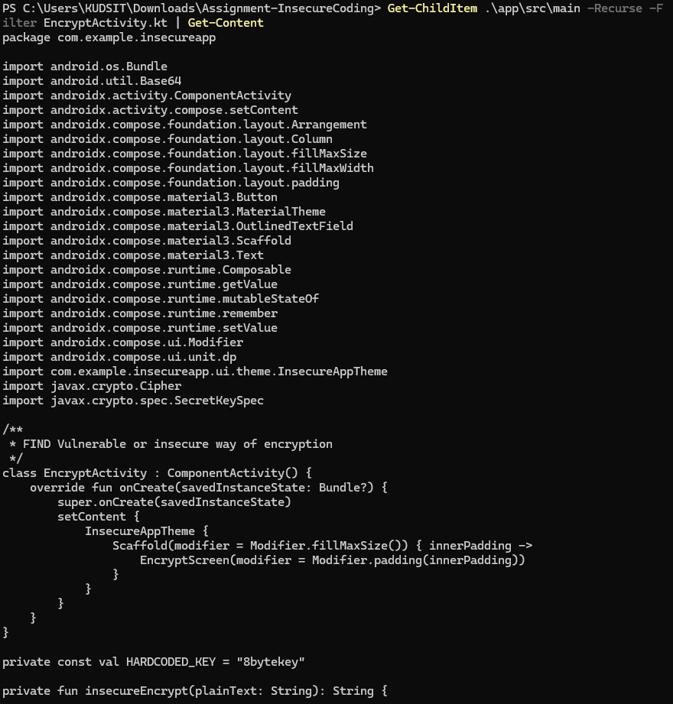
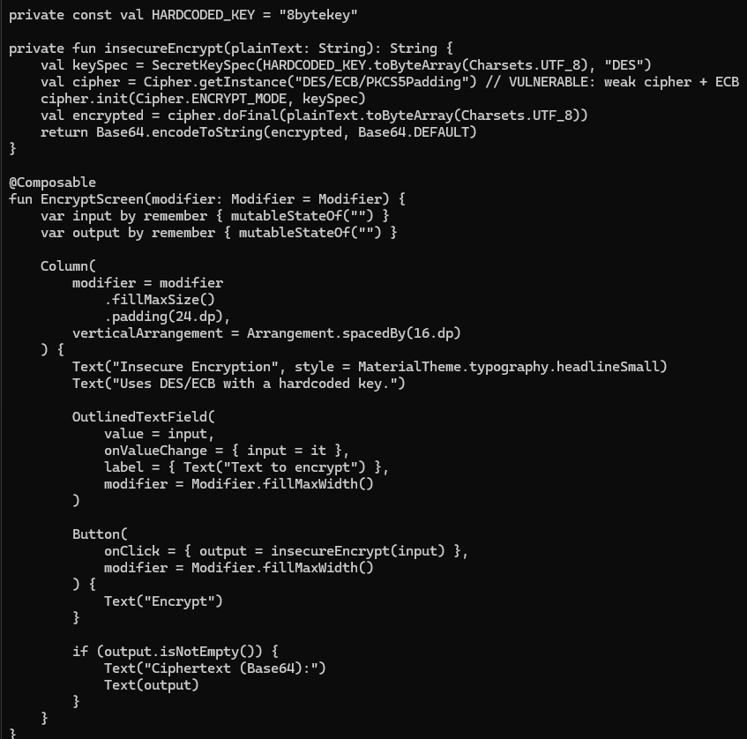
3.
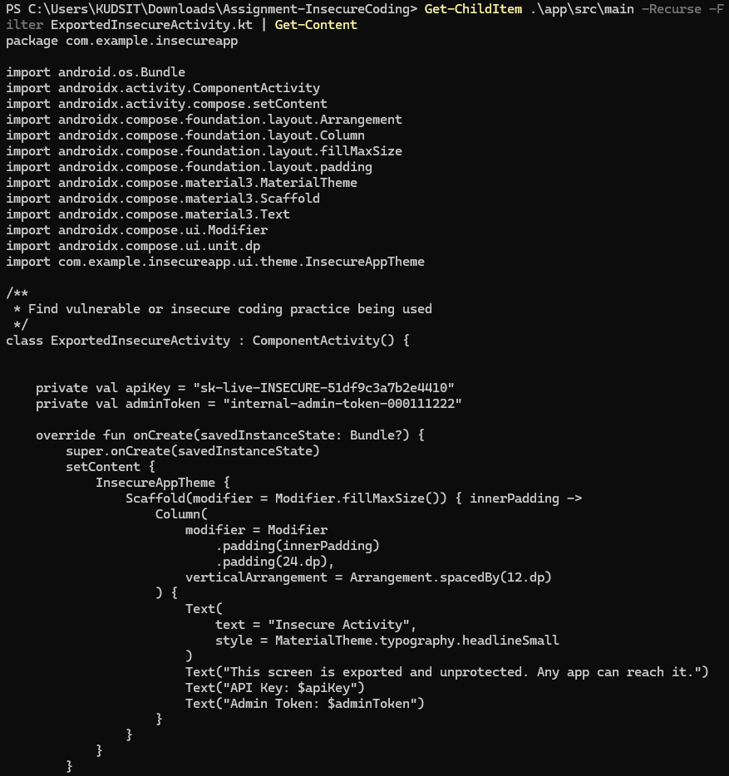

Task 2: Secure Code Snippets

1. Secure SQL Query – LoginActivity.kt

Insecure code
val query = "SELECT * FROM users WHERE username = '$username' AND password = '$password'"

Secure version
Use a parameterized query instead of directly concatenating user input:
val db = dbHelper.readableDatabase

val cursor = db.query(
"users",
arrayOf("username"),
"username = ? AND password = ?",
arrayOf(username, password),
null,
null,
null
)

val success = cursor.moveToFirst()
cursor.close()
Why this is secure:
The ? placeholders separate the SQL command from the user-supplied values, preventing the input from being interpreted as SQL code.
For a real application, passwords should also be properly hashed, not stored/compared as plaintext. For this assignment, the important fix here is parameterized SQL.

2. Secure Encryption – EncryptActivity.kt

Insecure code
private const val HARDCODED_KEY = "8bytekey"

val keySpec = SecretKeySpec(
HARDCODED_KEY.toByteArray(Charsets.UTF_8),
"DES"
)

val cipher = Cipher.getInstance("DES/ECB/PKCS5Padding")

Secure version
Use AES-GCM with a securely generated key and a random IV:
val keyGenerator = KeyGenerator.getInstance("AES")
keyGenerator.init(256)
val secretKey = keyGenerator.generateKey()

val cipher = Cipher.getInstance("AES/GCM/NoPadding")

val iv = ByteArray(12)
SecureRandom().nextBytes(iv)

val spec = GCMParameterSpec(128, iv)
cipher.init(Cipher.ENCRYPT_MODE, secretKey, spec)

val encrypted = cipher.doFinal(
plainText.toByteArray(Charsets.UTF_8)
)
Required imports:
import java.security.SecureRandom
import javax.crypto.Cipher
import javax.crypto.KeyGenerator
import javax.crypto.spec.GCMParameterSpec
Why this is secure:
AES-GCM provides authenticated encryption, avoids the weaknesses of DES/ECB, and uses a random IV instead of a fixed hardcoded encryption key.
For a production Android application, the generated key should preferably be stored using the Android Keystore rather than simply kept in application memory.

3. Secure Handling of API Keys / Admin Tokens – ExportedInsecureActivity.kt

Insecure code
private val apiKey = "sk-live-INSECURE-51df9c3a7b2e4410"
private val adminToken = "internal-admin-token-000111222"

Secure approach
Do not hardcode real API keys or administrator tokens inside the APK.
For example:
private fun getApiData(token: String) {
// Use a token obtained securely at runtime.
// Do not store permanent secrets directly in the APK.
makeAuthenticatedRequest(token)
}
And protect the Activity from unauthorized applications in the manifest:
<activity
android:name=".ExportedInsecureActivity"
android:exported="false" />
If the Activity genuinely needs to be accessed by another application, use an appropriate permission and authentication/authorization check instead of leaving it openly exported.
Why this is secure:
Secrets are not embedded directly in the application source/APK, and an Activity that does not need external access is prevented from being launched by other applications.

Task 2 Summary
Insecure practice | Secure coding practice
SQL string concatenation | Parameterized SQL query
DES/ECB + hardcoded key | AES-GCM + secure key generation + random IV
Hardcoded credentials + unprotected Activity | Secure runtime secret handling + exported="false"
Task 2 complete. ✅

Task 3: Associated Vulnerabilities

1. SQL Injection
Insecure coding practice:
The application directly concatenates the username and password values into an SQL query.
val query = "SELECT * FROM users WHERE username = '$username' AND password = '$password'"
Vulnerability introduced:
This can lead to SQL Injection, where specially crafted input may alter the intended SQL query. An attacker could potentially bypass authentication or access/modify database information.
OWASP Mobile Top 10:
M4 – Insufficient Input/Output Validation
This category covers inadequate validation of untrusted input, including injection-style vulnerabilities.

2. Weak Cryptography
Insecure coding practice:
The application uses DES/ECB and a hardcoded encryption key.
private const val HARDCODED_KEY = "8bytekey"

val cipher = Cipher.getInstance("DES/ECB/PKCS5Padding")
Vulnerability introduced:
DES is an outdated cryptographic algorithm and ECB mode does not provide adequate protection for structured data. The hardcoded key can also be extracted from the application. This can allow encrypted information to be recovered or compromised.
OWASP Mobile Top 10:
M10 – Insufficient Cryptography
OWASP's Mobile Top 10 identifies insufficient cryptography as the category covering weaknesses caused by improper or inadequate cryptographic protection.

3. Unprotected Exported Activity and Hardcoded Secrets
Insecure coding practice:
The application exposes an Activity using:
android:exported="true"
while the Activity contains sensitive credentials directly in the source:
private val apiKey = "..."
private val adminToken = "..."
Vulnerability introduced:
An exported Activity without appropriate authorization can potentially be invoked by another application. This can expose functionality that should be restricted.
The hardcoded API key and administrator token also expose sensitive credentials to anyone who can inspect or reverse-engineer the APK.
OWASP Mobile Top 10:
M3 – Insecure Authentication/Authorization for the unprotected exported component.
M1 – Improper Credential Usage is also relevant to the hardcoded credentials.

Final Summary Table
No. | Insecure Coding Practice | Vulnerability Introduced | OWASP Mobile Top 10
1 | SQL query built using user input | SQL Injection | M4 – Insufficient Input/Output Validation
2 | DES/ECB with hardcoded key | Weak/broken cryptographic protection | M10 – Insufficient Cryptography
3 | Exported Activity without authorization + hardcoded credentials | Unauthorized component access / credential exposure | M3 – Insecure Authentication/Authorization and M1 – Improper Credential Usage

✅ Day 3 is technically DONE.

